COVID-19 SCENARIO: A STUDY IN SHIFTING PARADIGM IN TEACHING
Yaduvir Singh1, Jyotsna Pandit2,Ankit Kumar2

¹Noida Institute of Engineering & Technology, Greater Noida
²Mangalmay Institute of Engineering & Technology, Greater Noida

ABSTRACT

In this paper, we have studied about the different modes that have been applied in the post Covid 19 scenario. The mode of teaching during this pandemic is online learning mode only and in this paper we analyze the different online learning platforms and the different learning management system used by the faculty member during this pandemic. This paper analyzes the usage of the LMS and online learning tools. In this paper we also compare the different tools by performing the statistical analysis on them. The analysis is made among 400 respondents from different organizations having 0 to 10+ % of teaching and administrative experience. The results show that 75.6% of the participants are satisfied with online teaching learning process but they don’t want it to continue for long. Almost 78.9% participants have marked offline classroom teaching as their 1st preference. On enquiring about their willingness to join Offline classes post Covid,
41.3% participants agreed for classroom teaching but with small batch size and effective social distancing. Lastly, the comparison between online and offline teaching methodology is done and the conclusions are drawn as per the analytical results obtained. The pandemic also developed several futures prospective in terms of digital teaching methods, alternatives, online teaching, distance learning, etc. The deduction of our study shows that the teachers will prefer the blended form of the learning (combination of the online and offline mode of learning) rather than only online mode of learning.

KEYWORDS: LMS, learning analytics, MOOC

1. INTRODUCTION

The learning plays an important role in the field of the human being and pre Covid-19 we are mainly focus on the classroom teaching and the student interact with teachers to find the solution of their problems. The Pre Covid 19 online learning mode exists but used as per the customized requirements or the universities or colleges where online mode of learning already exists.

The Post Covid 19 scenario has forced the learners and teachers to take this as the only option to interact with the students; this allows the online learning tools and different LMS to exist as per the different companies. The learning depends upon the different types of learners which allows to grasp the concept as per the IQ level of the learner [1].

E-Learning: The usage of E-learning [2] allows the user to apply the fundamentals of the recent platform of the learning in the real scenario. It is a platform [3] mostly used by the person after
the Covid-19 period and it becomes an opportunity for all the educationalist to include the E- learning in their mode of teaching. The different type of learning styles and strategies [4] re dependent on the user either he or she will prefer the online mode of learning or the blended form of the learning as per the requirement. Online learning [5] plays a bigger role for the current user who always prefers the ICT (Information and Communication Technology) mode of communication in the current pandemic situation, as the normal mode of the learning is not at all possible. The different users are also inclined towards the Massive open online courses (MOOC) [6] in current situation and it is a win win situation for both the learners and the facilitators.

1.1 Learner and its Categories:

a. Visual learners: The learners who tend to learn by the visual effect means by seeing the things [7, 8].
b. Kinesthetic learners: The learners who tend to learn by doing the things.
c. Read/Write learners: The learners who learn by reading or writing the things. d. Auditory learners: The learners who learn by listening the things.
e. Natural learners: The learners who try to learn how they perceive the things.
f. Logical/Mathematical Learners: These types of learners learn by logical thinking or solving the things.
g. Musical/Rhythmic Learners: These types of learners tend to learn by turning on the
Music on or by following particular rhythms.

The scenario of post Covid 19 allows the teacher to use the Online teaching strategies for the interaction with the students and the teacher should include these concepts in the teaching methodology.

a. Mock session
b. Acquaintance with the class c. Work culture
d. Technology Usage
The online teaching [9] allows using the flipped classroom and mock session type of strategies to get the advantage of the technology. Learning styles also play a role to play in online teaching as it depends upon the students how he perceives the thing.

2. ONLINE LEARNING TOOLS

The Online teaching involves the different online learning [10] tools associated with it, which allows the teacher to effectively communicate with the students. The different online video conferencing tools that are being used for teaching also are as follows:

a. ZOOM
b. CISCO WEBEX
c. GO TO MEETING
d. MICROSOFT TEAMS
e. GOOGLE HANGOUTS/GOOGLE MEET
f. RING CENTRAL
g. SKYPE
h. JIOMEET

The different features associated with the different online learning are:

a. User Interface
b. Video Conferencing c. Personal rooms
d. Hat Active speakers e. Chat/Polling
f. Recording /editing /playback meeting g. Active speaker
h. Document/Application/Screen sharing i. Annotations on /off
j. Admin Permission User specific

These are the certain features that are included in almost all of the mentioned online learning tools available and the user can use any one of the above as per the specific requirement.

3. LEARNING MANAGEMENT SYSTEM

The different learning management system [11] also plays an important role in the online learning strategy. The different learning management systems are as follows:

a. Moodle
b. Bodhi Tree c. Chamilo
d. Open Edx
e. Tatara Learn f. Canvas
g. Edu Me
h. Skill Cast LMS
i. Coassemble
j. 360 learning engagement platform k. Loop

Learning Management System facilitates students to access videos anytime. Though this may not be suitable if the instructor prefers an active audience, LMS has many added advantages in terms of progress of learners. Their responses for different activities such as assignments, quizzes can be recorded and managed. This helps the instructors, generally with a large number of audiences.
4. REAL TIME DATA ANALYSIS OF ALMOST 400 RESPONDENTS
The different learning management system used by the Director, Professor, Assistant Professor, Researcher and the different management person working in the organization.
We have collected the data and plotted the different real time Pie Chart for the analysis of our collected data. The analysis shows you how the teachers are really shifted the gears from the Offline mode to the online mode of the learning in this duration of the pandemic.

5. RESULT AND DISCUSSION
The Pie Chart and Bar Graph of the different participants collected in the sample data set. The results have been obtained in a detailed manner and we constructed survey in different parts. Part 01:
The details of the different post held by the different respondents are depicted with this pie
chart and this shows that highest respondents with reference to our collected data belongs to the class of the Assistant Professor. This can be seen in the result obtained as depicted in fig. 1.

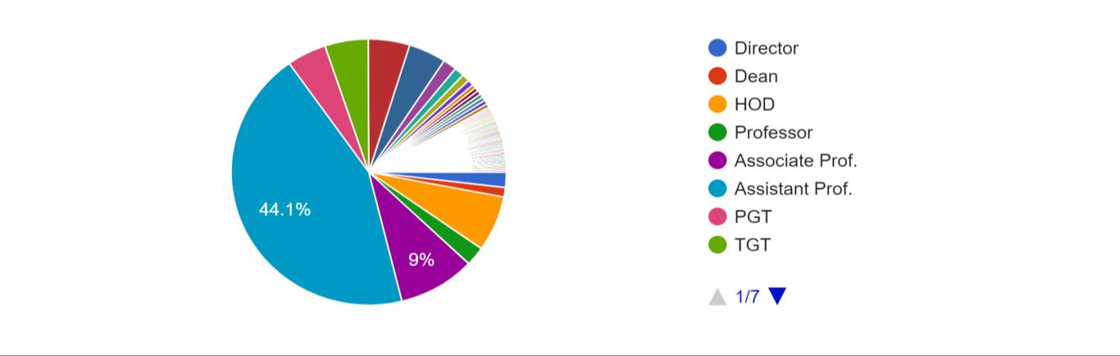

Figure. 1. Position Held at Institute

Fig. 2 shows active use of paid online platforms. This gives us an idea about the preference of participants and their willingness to buy online conferencing platforms.

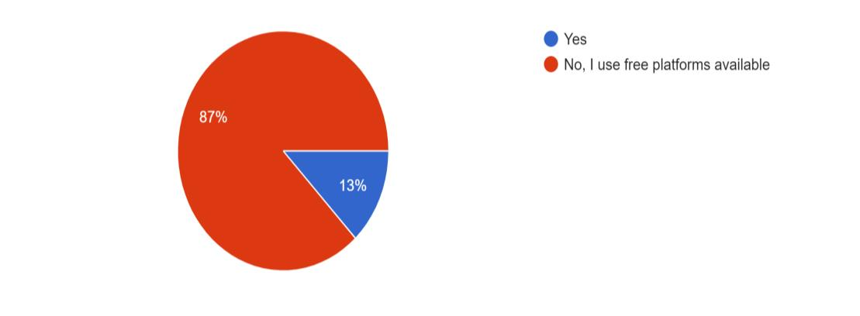

Figure. 2. Purchase of Platform

Similarly, figure 3 shows the teaching experience of the participants. This shows that participants are of different age and gives a detailed view of all the participants irrespective of their teaching experience or ease with technology.

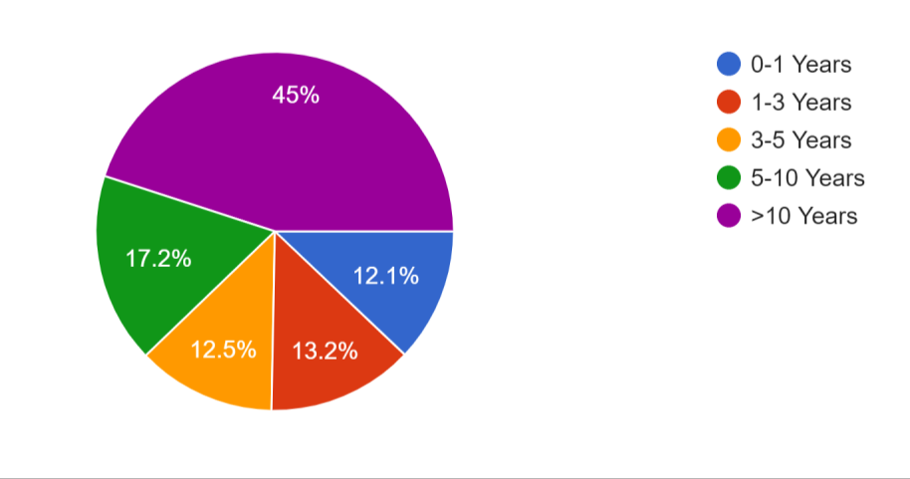

Figure. 3: Teaching Experience

On the basis of their experience we have asked participants to suggest online platforms for their peers. For this analysis we provided various know and commonly used platforms ; also giving them the option to suggest the platforms which we might have missed as their experience and areas differ. From fig. 4 it is clear that most of the participants suggested ‘Zoom’ at 37%with
‘Google Meet ‘ coming close to second at 34.6% partcicipants. This can be attributed to two
common reasons;

a. Better advertisement and reach by the pnline platform. b. Ease of technology offered or user friendly interface
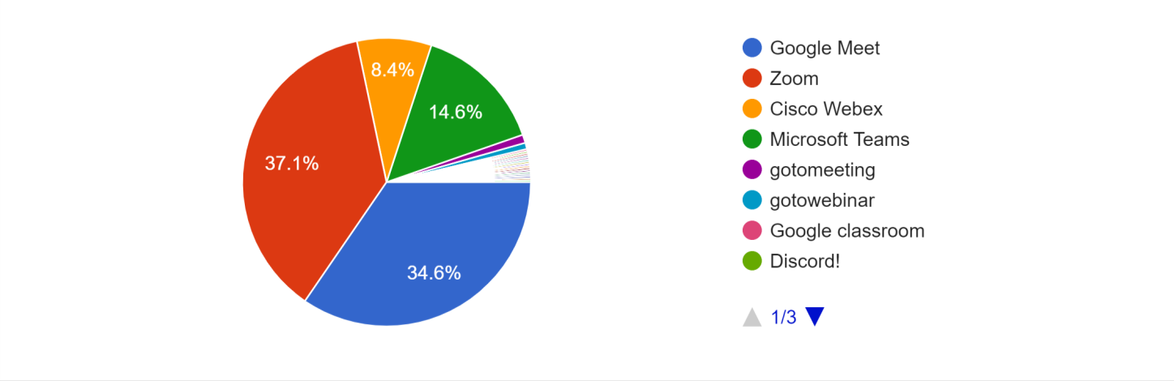

Figure. 4. Platform Suggested to peers

Part 02:
This brings us to our next part of the review. The next part deals with use of LMS. This is due to fact that most of the teachers prefer online conference platforms for interacting with students but tracking their progress requires continuos evaluation. This can be made easier if the performance of each student is collected in a same database for comparison and evalutaion.
The following fig. [Fig. 5] represents which LMS have been used by the participants in the survey. From the bar chart it is clear that Google Classroom was mostly used by participants.

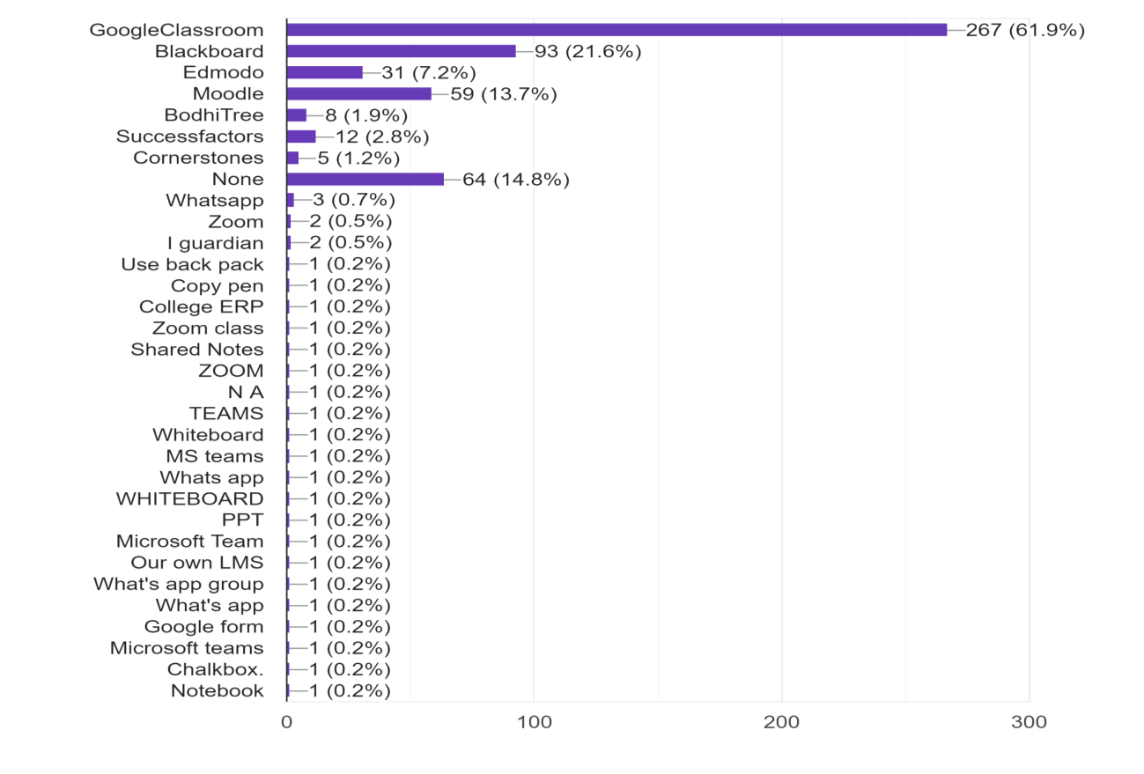

Figure. 5. LMS used by participants
We have also taken in account if an institute has asked paticipants to use a particular platform. The reasons for this may vary – it might be that the institute has bought a platform of its own or to consolidate the performance of each student at institute on a single platform. The prefernce of institutes has been shown in Fig. 6.

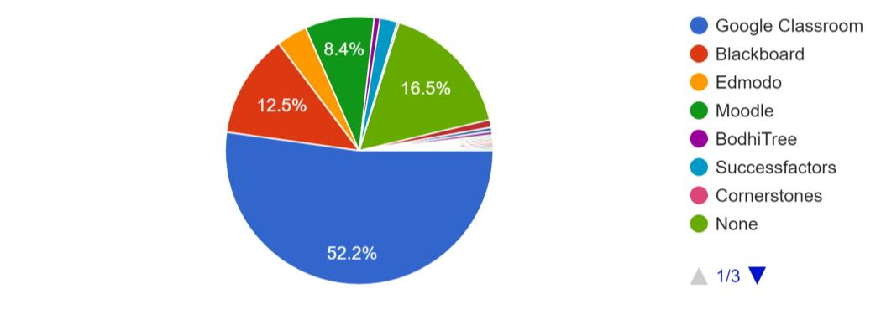

Figure. 6. Platform Suggested by Institute

On the basis of their experience with LMS we asked the participants to suggest their peers. Their suggestions ahev been depicted in Fig. 7. From the pie-chart it is clear that the participants have mostly suggested google classroom. This again may be attributed to different reasons:

a. Better marketing by the LMS. b. Ease of use
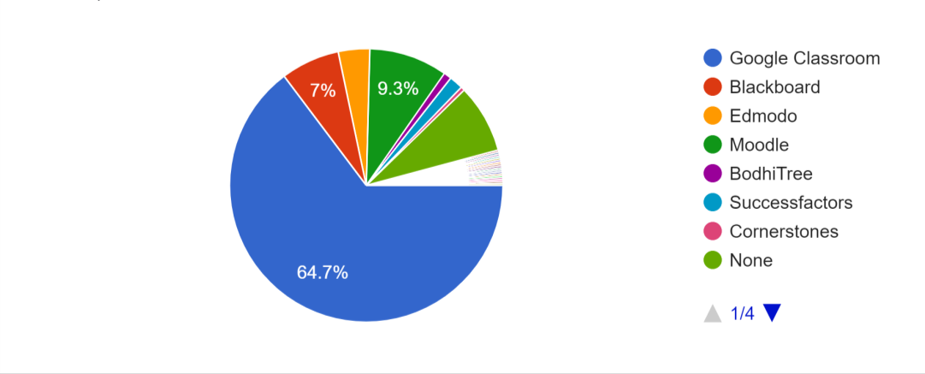

Figure. 7. Platform Suggested to peers

Part 3:

This brings us to the third review. Every teacher is satisfied when the students response. This has been surveyed with the participants in next analysis.
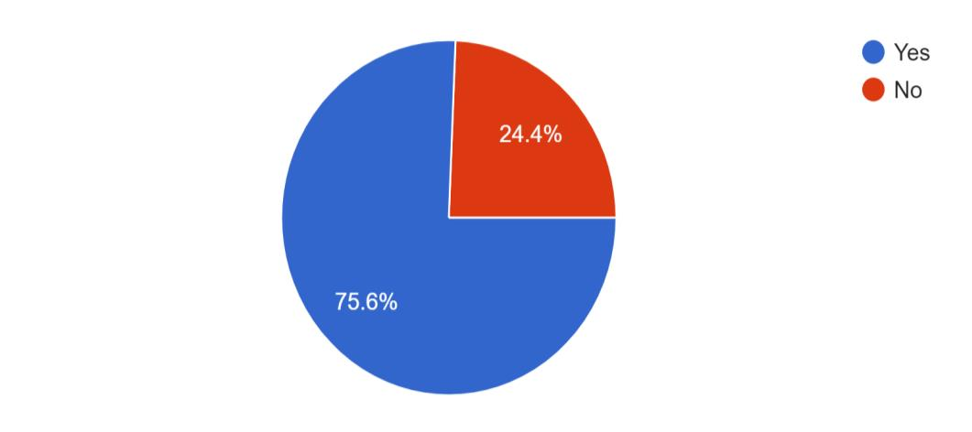

Figure. 8. Satisfaction with Students’ Response online

Part 4:
The next part has been done in view of various parameters for students’ response on LMS and online video conferencing platforms. This also gives a comparative study on LMS and online conferencing platforms. Fig. 9(a) and 9(b) gives rating of ‘discipline’ of students on online video platform and features in online video platforms respectively. From figures it can be clearly seen that most participants have responded favorably in terms of discipline of their students.
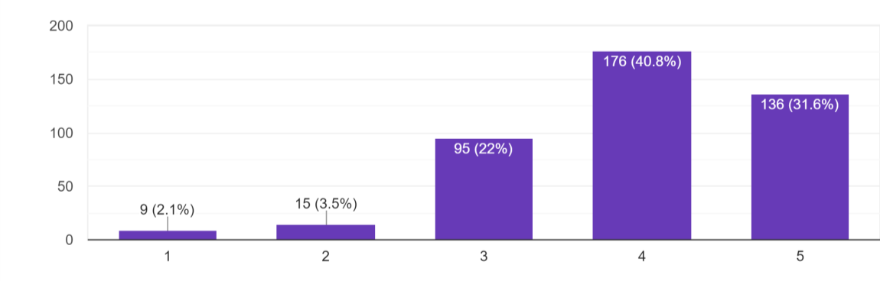

Figure. 9 (a): Discipline of students as rated by participants on online video platforms (1 being very poor and 5 being excellent)

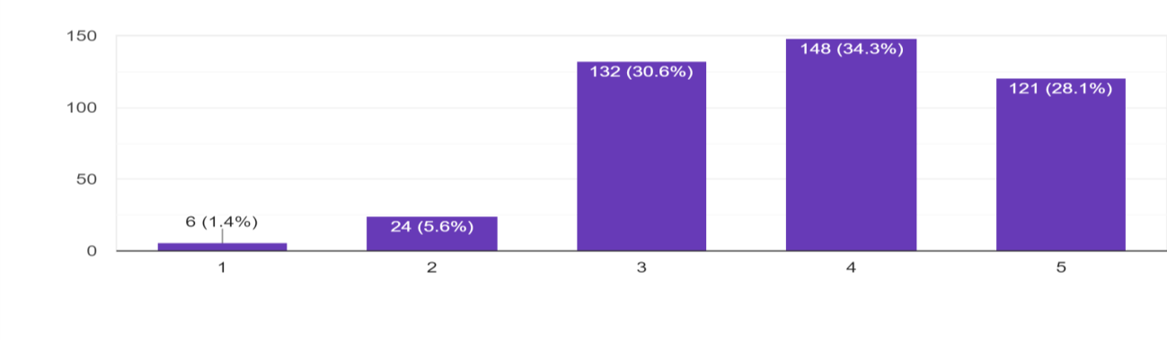

Figure. 9(b). Rating of features in Online Video Platforms by participants to avoid nuisances (1 being very poor and
5 being Excellent)
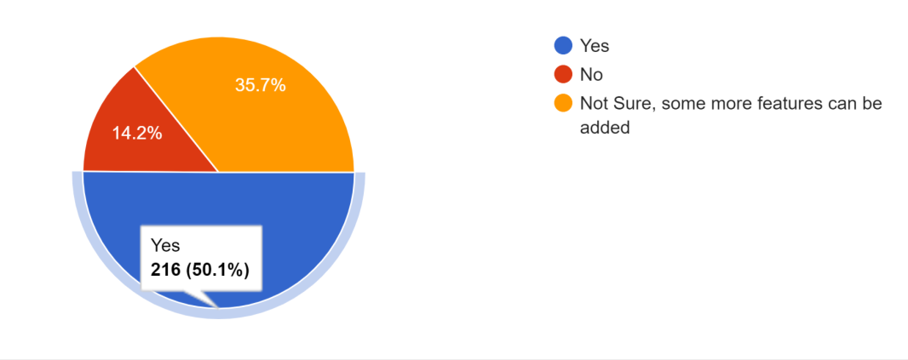

Figure.10. Rating of features in Online Video Platforms by participants to avoid nuisances

Fig. 10 shows rating of features on online video platforms to avoid nuisance on online platforms. This has been done to get a review on whether improvement of features are required. The next part shows the responses for same questions but in respect to LMS.

Part 5:

Fig. 11 shows overall satisfaction level of participants in regard with discipline on LMS.

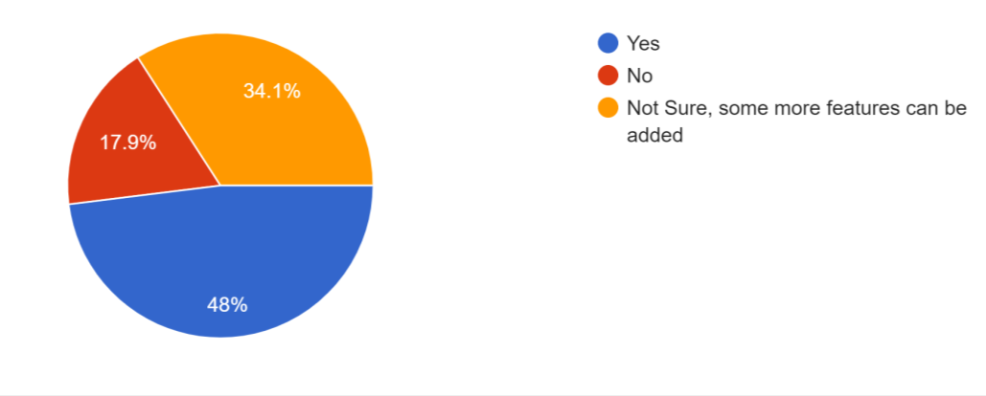

Figure. 11. Satisfaction with Features on LMS regarding discipline

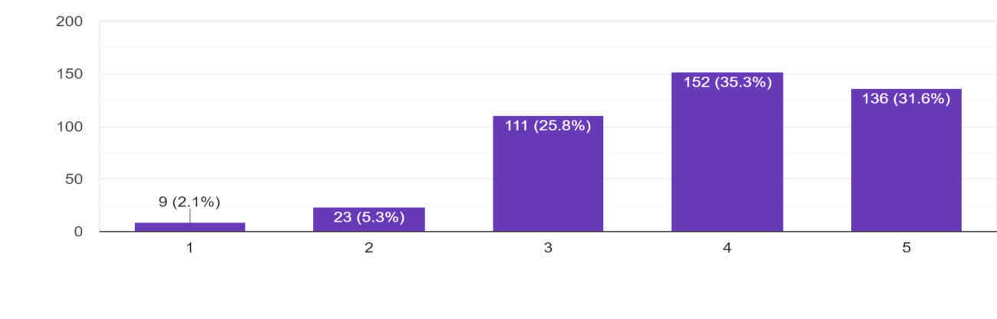

Figure. 12. Satisfaction with students’ discipline on LMS

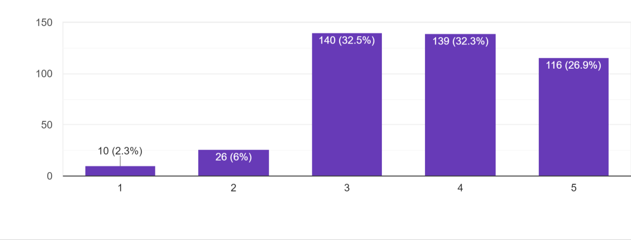
Figure. 13. Rating of Features by participants on LMS regarding discipline

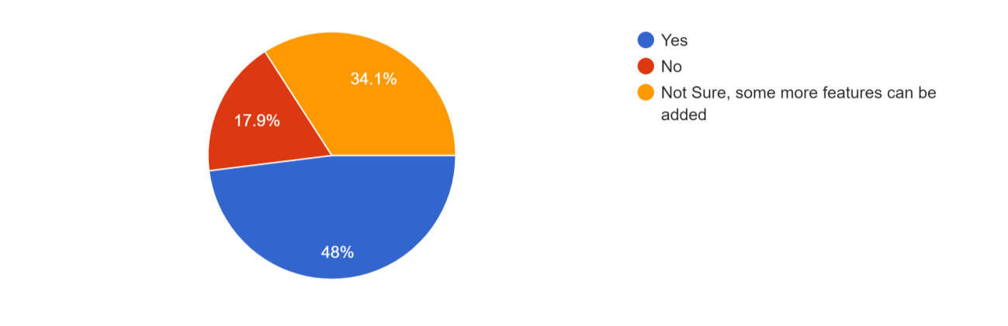

Figure. 14. Satisfaction with features in LMS

Fig. 12 and 13 rates the satisfaction level with students on LMS and features in LMS in this regard respectively. Fig. 14 shows an inquiry to whether features on LMS can be improved or not. As discipline can be termed to various attributes, we have also conducted survey on essentials for a students progress. Fig. 15 shows response to of participants on wheteher the students respond to assignment in time. It should be noted that there may be other factors as availability of cell services to students’ region but even after counting such factors the response is generally favorable as can be seen in the pie chart.
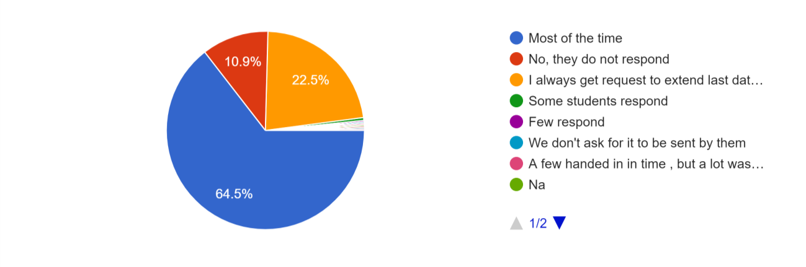

Figure. 15. Response of students to assignments in time

As to the factors mentioned in the discussion, we have surveyed the participants to their view of effort by students to complete tasks given to them in time.

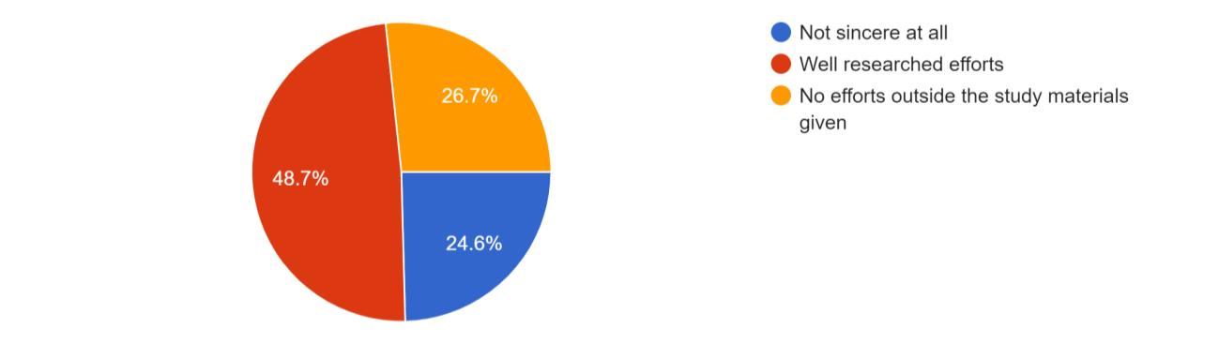

Figure. 16. Students’ Effort to assignments in time

The next part gives comparison on online to classroom teaching by participants.

Part 6:

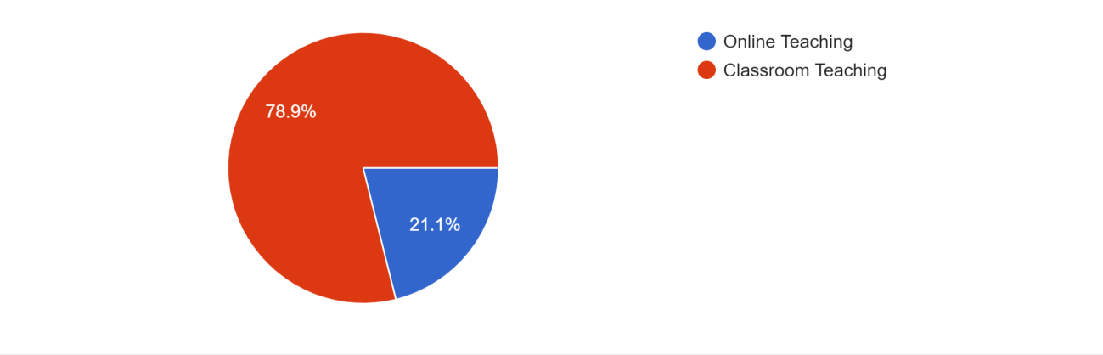

Figure. 17. Participants’ Preference

Most of the participants still find classsroom teaching as their preference as shown in fig. 17. To further inquire in this area we posed the questions by providing them different scenarios. Fig. 18
depicts these four scenarious and records participants’ response. We asked the question in term of Covid -19 and found that in case of a pandemic, the participants prefere onlien teaching over safety norms to be followed.

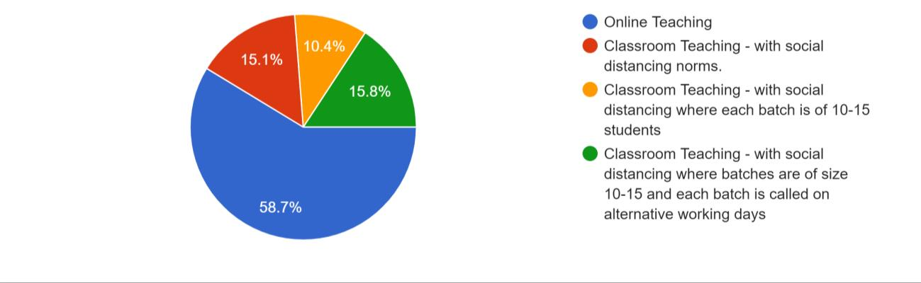

Figure. 18: Participants’ Preference after lockdown

This brings us to our last part of the survey. As in case of pandemic most participants preferred online classroom mode, we still wanted their view on LMS and online video platforms. Fig. 19 shows their preference. Most of the participants required both. This shows that a platform which could provide both live interaction and management of progress would be an ideal solution.

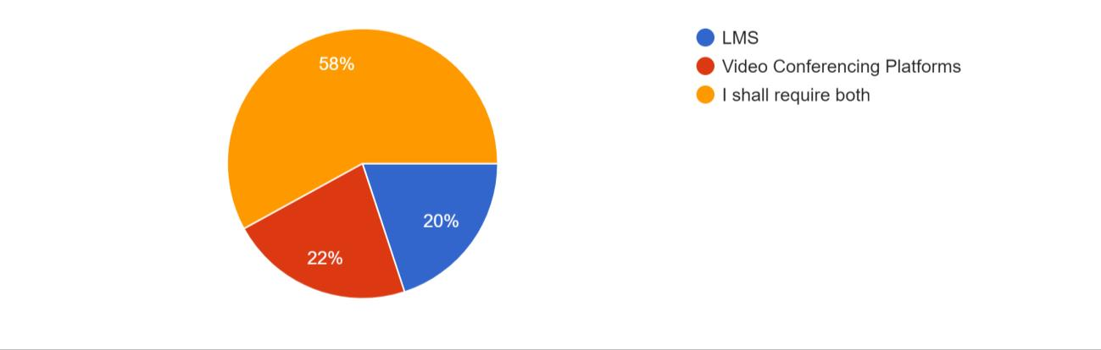

Figure. 19. Participants’ Preference among LMS & Conferencing Platforms

To find a detailed view we also considered many factors such as effect on their health, their best performance, economical and time required. Fig 20 finds comparison for these factors between online and offline mode.
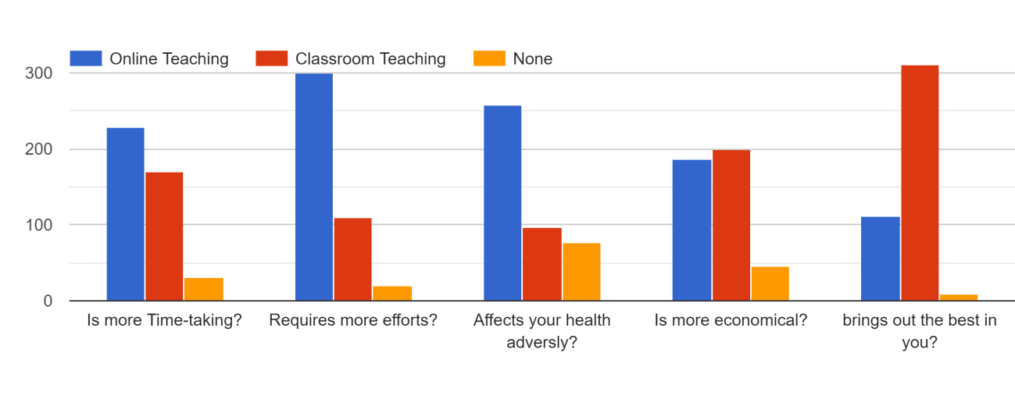

Figure. 20: Comparison between Online & Classroom Teaching on various factors

6. DETAILS REPORT OF THE STUDY

After collection of almost 400 respondents we can confirm that the data collected and its analysis will give you a picture that the teachers are switching over from the offline mode of learning to the online mode of learning but the road ahead for implementing it in the real sense is not an easier one.

The usage of the different Learning management system and different video conferencing tools [12] are in the middle phase of the learning and as per our analysis it is the blended mode of learning that most of the teachers will follow.

7. PLS-SEM:

PLS-SEM is defined as Partial least Square Method for Structure Equation Modelling that is second-generation multivariate Data Analysis method that is often used in marketing research because it can test theoretically supported linear and additive causal models.
It contains two submodels in a structural equation model; The inner model that specifies the relationships between the independent and dependent latent variables, whereas the outer model specifies the relationships between the latent variables and their observed indicators(fig.1).

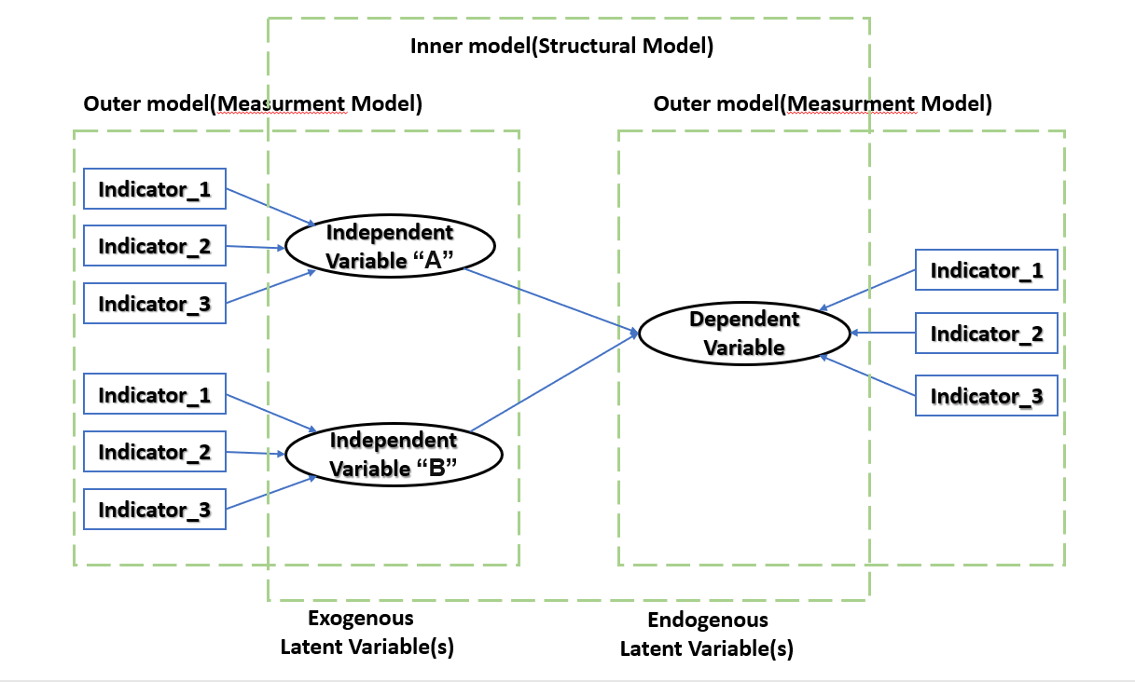

PLS-SEM: PLS is a soft modeling approach to SEM with no assumptions about data distribution. Thus, PLS-SEM becomes a good alternative to CB-SEM when the following situations are comes.

1. Sample size is small.
2. Applications have little available theory.
3. Predictive accuracy is paramount.
4. Correct model specification cannot be ensured.
On the other side PLS-SEM is not appropriate for all kinds of statistical analysis. People also need to be aware of some Limitations of PLS-SEM, these are as follow’s:
1. High-valued structural path coefficients are needed if the sample size is small.
2. Problem of multicollinearity if not handled well.
3. Since arrows are always single headed, it cannot model undirected correlation.
4. A potential lack of complete consistency in scores on latent variables may result in biased component estimation, loadings and path coefficients.
5. It may create large mean square errors in the estimation of path coefficient loading.

In spite of these limitations, PLS is useful for structural equation modeling in applied research projects especially when there are limited participants and that the data distribution is skewed. PLS-SEM has been deployed in many fields, such as In Marketing , Business Stratergy, Behavioral sciences,
SmartPLS applied:
An example, The following customer satisfaction example will be used to demonstrate how to use the SmartPLS software application.
Customer satisfaction is an example of a latent variable that is multidimensional and difficult to observe directly. However, one can measure it indirectly with a set of measurable indicators that serve as proxy. In order to understand Customer Suggestion, a survey can be conducted to ask Online Teaching During Covid-19 (Learning Management System(L.M.S), Online Application) about their Feature’s. In this survey , Peoples related to academics are asked to rate their experience on a scale representing Customer Suggestion(CS), Customer Review(CR) using a 5-Point likert scale.

Fig: Conceptual Framework – Online Teaching During Covid-19

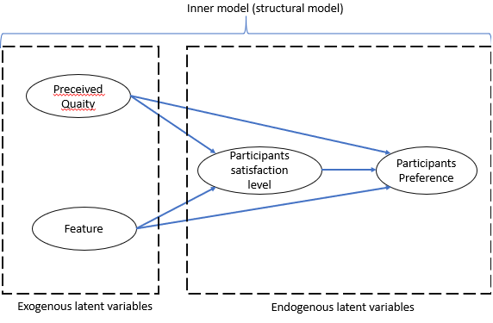

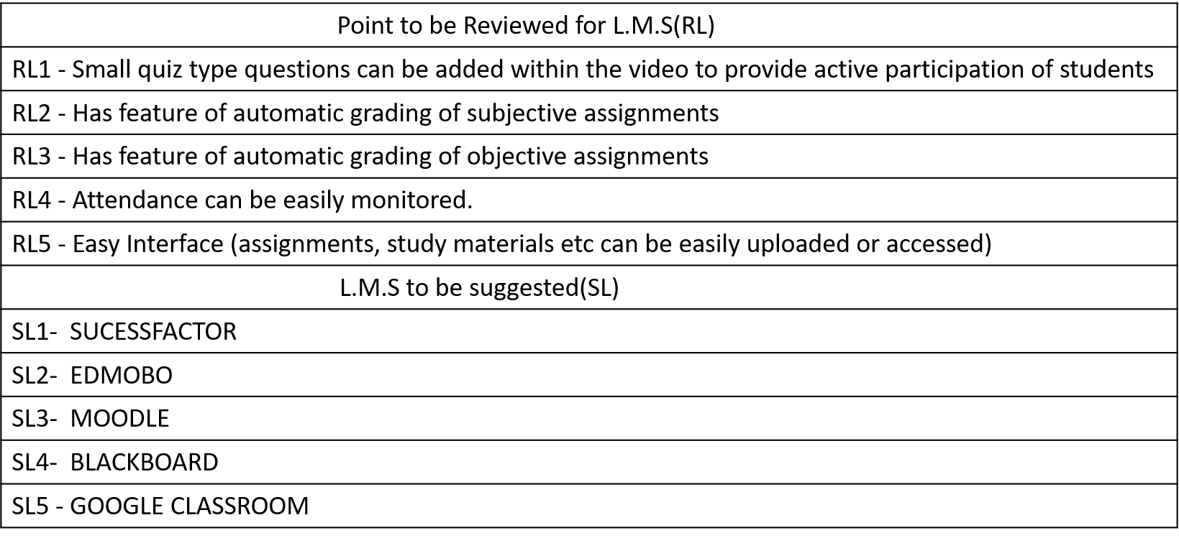
For L.M.S here we take some indicating point related to Suggestion(SL) and Review’s(RL) ar
Point to be Reviewed for Online Application(OL)
RL1 – Other
RL2 - Small quiz type questions can be added within the video to provide active participation of students
RL3 - Provides facility for recording of lectures
RL4 - Chats can be controlled and monitored by administrator easily
RL5 - Attendance can be easily monitored
Online Application to be suggested (OL)
SL1- GOTO WEBMEETING
SL2- CISCO WEBEX
SL3- TEAMS
SL4- GOOGLE MEET
SL5 – ZOOM
For Online Application here we take some indicating point related to Suggestion(SO) and Review’s(RO) are,

In the actual survey more than these feature option are provided However, the top five features, with highest frequency have been considered, the other feature were not weighed as much by participant. Therefor only these feature having highest frequency were considered for the Analysis.

Fig: Dataset from the Online Teaching Example

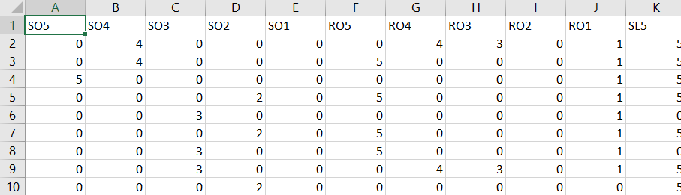

Fig: Building the Inner Model

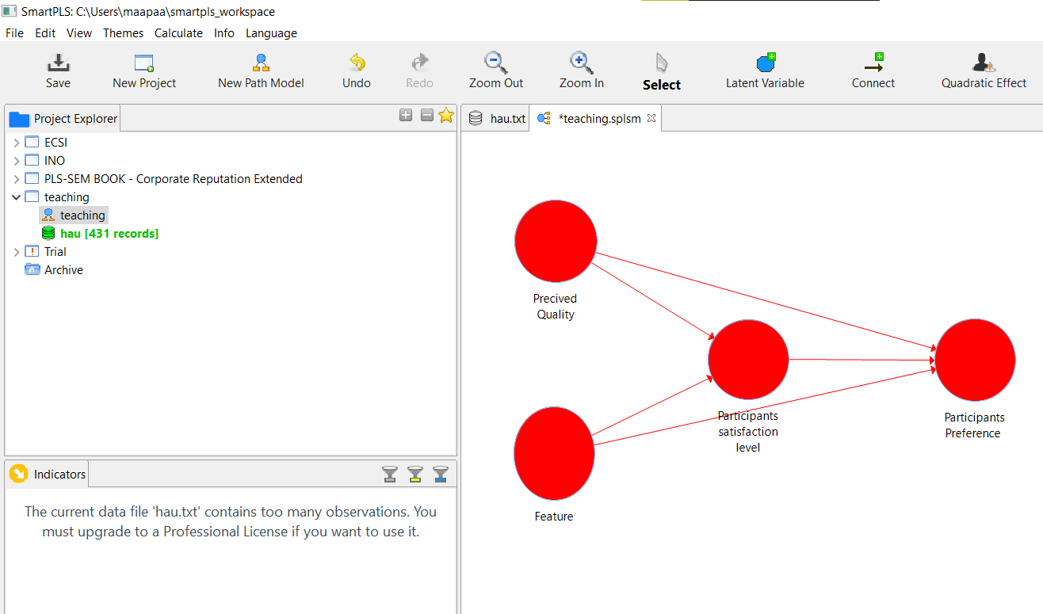

7. CONCLUSION

In this paper we have analyzed different video conferencing tools used for the online learning and the different learning management system used by the teachers in this pandemic period. The real analysis shows that the teachers are initially in the learning phase of the different video conferencing tools and different learning management system. With the progression of the time the teachers are adapting themselves with both.

From the elaborative study made above, we can finally conclude that

a. There are several online platforms working fir online teaching learning during Covid-19 like ZOOM, CISCO WEBEX, GO TO MEETING, MICROSOFT TEAMS, GOOGLE HANGOUTS/GOOGLE MEET, RING CENTRAL, SKYPE, JIOMEET etc.

b. Different Features associated with the tools are User Interface, Video Conferencing, Personal rooms, Hat Active speakers, Chat/Polling, Recording /editing /playback meeting, Active speaker, Document/Application/Screen sharing, Annotations on /off, Admin Permission User specific etc.
c. Several LMS used in India are Moodle, Bodhi Tree, Chamilo, Open Edx, Tatara Learn, Canvas, Edu Me, Skill Cast LMS, Coassemble, 360 learning engagement platform and Loop.

d. Analytical data from around 400 participants concludes that 75.6% of the students are
satisfied with online teaching learning process but they don’t want it to continue for long.

e. Almost 78.9% students have marked offline classroom teaching as their 1st preference.
On enquiring about their willingness to join Offline classes post Covid, 41.3% participants agreed for classroom teaching but with small batch size and effective social distancing.

The deduction of our study shows that the teachers will prefer the blended form of the learning (combination of the online and offline mode of learning) rather than only online mode of learning.

8. FUTURE SCOPE

In future we people will perform the statistical analysis of our sample data and try to deduce the result that, which video conferencing tools and the learning management systems are preferred by the teachers in a real scenario. In our other research paper we people will collect the data from the students and perform the real data analysis with respect to both video conferencing tools and learning management system. The pandemic also developed several futures prospective in terms of digital teaching methods, alternatives, online teaching, distance learning, etc. Many new business models are developed in this regards.

References:

[1] E-Learning: Challenges and Research Opportunities Using Machine Learning & Data Analytics ABDALLAH MOUBAYED 1 , MOHAMMADNOOR INJADAT1 , ALI BOU NASSIF2 , HANAN LUTFIYYA3 , AND ABDALLAH SHAMI1 1Electrical and Computer Engineering Department, Western University, London, ON N6A 3K7, Canada 2Electrical and Computer Engineering Department, University of Sharjah, Sharjah, United Arab Emirates 3Computer Science Department, Western University, London, ON N6A 3K7, Canada Digital Object Identifier 10.1109/ACCESS.2018.2851790
[2] E-Learning Inc. (2016). About E-Learning. [Online]. Available:
http://www.elearningnc.gov/about_elearning
[3] T. Ayodele, C. A. Shoniregun, and G. Akmayeva, ‘‘Towards E-learning security: A machine learning
approach,’’ in Proc. Int. Conf. Inf. Soc. (i-Society), London, U.K., Jun. 2011, pp. 490–492.
[4] R. Felder and B. Soloman. Learning Styles and Strategies. Accessed: Mar. 1, 2018. [Online].Available:http://www4.ncsu.edu/ lockers/users/f/felder/public/ILSdir/styles.htm
[5] F. Mayadas, G. Miller, and J. Sener, ‘‘Definitions of E-learning courses and programs, developed for discussion within the online learning community,’’ Online Learning Consortium, Newburyport, MA, USA, Tech. Rep. Version 2.0, Apr. 2015. [10] B. Tucker, ‘‘The flipped classroom,’’ Educ. Next, vol. 12, no. 1, pp. 1–6, 2012.
[6] D. Shah. (2016). By The Numbers: MOOCS in 2016. [Online]. Available: https://www.class- central.com/report/mooc-stats-2016/
[7] D. Clark. (2011). Visual, Auditory, and Kinesthetic Learning Styles (VAK). [Online]. Available:
http://www.nwlink.com/~donclark/hrd/ styles/
[8] Southwestern Community College. The VAK Learning System. Accessed: Mar. 1, 2018.
[Online].Available: http://www.southwesterncc.edu/sites/ default/files/VAK_Learning_Styles.pdf
[9] Best Practices in Online Teaching Strategies, Hanover Res. Council, Washington, DC, USA, Jul. 2009
[10] Digital learner presence and online teaching tools: higher cognitive requirements of the online learners
for the effective learning, Research and practice in technology enhanced learning ,Vol 12,Article
number :18(2017)
[11] A survey paper on e-learning based learning management Systems (LMS), Chirag Patel, Mahesh Gadhavi,
Dr. Atul Patel, International Journal of Scientific & Engineering Research, Volume 4, Issue 6, June -2013
171 ISSN 2229-5518
[12] https://www.ictacademy/Digital Learning/Program Guide
[13] Partial Least Squares Structural Equation Modeling (PLS-SEM) Techniques Using SmartPLS, Ken
Kwong-Kay Wong, Marketing Bulletin, 2013, 24, Technical Note 1

